Version
3
The Tactical Development Group
William Lewitt, CCEMT-P/RN
Tactical First Aid
The Tactical Development Group
Tac1Aid: Emergency Treatment of Knife and Gunshot Wounds
The Tactical Development Group©
15b Forbes Street
Jamaica Plain, MA 02130
Phone 617.304.0648 • Email Tac1Aid@hotmail.com

Forward to Tac1Aid 3.0

In 1998 I was wrapping up my paramedic training at the University of Texas Health Science Center, San Antonio. The same year the United States Special Operations Command mandated that all SOF medics obtain their civilian EMT-Paramedic certification The UTHSCSA Department of Emergency Medical Technology began running a ten week compressed paramedic program that totaled over 450 hours of training for 18-D SF Medics, the culmination of which was the National Registry Paramedic exam. I began sitting in on the classes to supplement the lectures I was receiving as part of my civilian program and volunteering as a “victim” for the patient care scenarios that the medics had to perform. Tactical medicine at this point was almost strictly a military concept. The CONTOMS program was still up and running, but there was very little else in place to train a paramedic to provide care in either a dynamic tactical environment or remote and austere environments.

The concept for tactical first aid revolves around one simple truth: It’s easier to teach a skilled operator the concepts of advanced first aid than it is to teach a paramedic to be proficient in close quarter battle. For law enforcement agencies, military units operating in forward areas and civilian shooters, the skills presented in the tactical first aid curriculum can greatly enhance the survivability of shooters should the worst happen. This lifesaving skill set revolves around three basic tools: pressure dressings, tourniquets, and hemostatic powders.

Tourniquets in civilian EMS have always been controversial. The only thing more controversial has been the introduction of hemostatic agents such as QucikClot, HemCon, and Celox. When I first developed and wrote this manual, many of the therapies I was advocating were considered heresy. In the 2008 update of the Prehospital Trauma Life Support Manual, the “radical” ideas I had been pushing then were adopted as the standard of care. Medicine is a constantly evolving field. Evidence-based practice constantly evaluates the most current data to ensure that current therapies and treatments are performing as advertised. This, combined with the advances in trauma medicine coming out of the battlefields of Iraq and Afghanistan, have lead to two major editorial changes in this manual:

- Tourniquets should be applied BEFORE the application of hemostatic powders. At this point Tac1Aid only recommends the use of two specific tourniquets: the SOF-T and the CAT-T. This is based on the results of the US Army Institute for Surgical Research trials.

- There are several hemostatic powders and agents on the market currently. The only hemostatic powder advocated for use at this time by Tac1Aid is Celox. This is based on the first hand reports of Physicians from the 10th Mountain Division and their experiences in Afghanistan.

This program was taught for four years at the SigArms Academy and was attended by students from multiple teams in the special operations community as well as law enforcement agencies of every kind. This manual has been peer-reviewed and editorially approved by members of medical community including physicians who provide Tactical Medical Direction. The tactical first aid curriculum has been approved for continuing education credits from the Massachusetts Office of Emergency Medical Services, and EMT’s from around New England have attended.

I have done my best to ensure that the tactical first aid curriculum adheres to the highest standards and is compliant with the American College of Surgeons ATLS and PHTLS, The Committee for Tactical Casualty Care, and the University of Maryland Baltimore County Critical Care Paramedic curricula. However, this manual is of course not meant to substitute for the protocols of any state or agency or as a substitute for the direction of a physician.

Please feel free to contact me with any editorial concerns or questions about the manual. I value the input of operators and clinicians in the field. I will also attempt to distribute updates to the manual as there are changes in the standard of care which affect this material.

Bill Lewitt
Tac1Aid@hotmail.com
August 2009
Table of Contents

Forward i
Chapter1-The 5 Ws of Tac1Aid 1
What is Tactical First Aid? 1
When and Where do we Need It? 2
Who Needs It? 2
How do we do It? 3
Why do we do It? 3
Chapter 2- The History of TEMS 5
The Origins of Battlefield Medicine 5
EMS Today 6
Tactical First Aid 7
Chapter 3-The Myths of Trauma 8
He’s Only Got a knife… 9
Howdy, Partner! 10
If it’s Stuck, Leave It! 11
If There’s a Hole, Plug it! 11
Speed and Lethality 13
Chapter 4-The Truths of Trauma 14
The truth about Shock 14
The truth about Blood Loss 18
Estimating Blood Loss 19
Overt Blood Loss 20
Occult Blood Loss 21
Space and Potential Space 21
The Pneumothorax 22
Lies, Damn Lies, and Statistics 26
Chapter5-
The Theory and Practice of Tac1Aid 27
The Death of General Johnson 28
CPR Under Fire 28
The Exception to the Rule 29
Spinal Immobilization 29
Tourniquets 30
The Practice of Tac1Aid 31
The Toohey Amendment 31
The Primary Survey 32

Chapter 6-Treatment of Trauma 34
Chapter 7-
Advances in Medicine: The Bloodless Battlefield 37

Chapter 8
Tactical Patient Movement 41

The Five W’s Of Tac1Aid
Chapter
1
When I developed this class, I had in mind a program that would dispel many of the myths around knife and gunshot wounds as well as to teach students the skills necessary to effectively treat those injuries in the field. The media abounds with not only inaccurate portrayals of trauma and its effect on the human body, but also many dangerous and possibly fatal methods of “first aid.” After taking this class the student should know the difference between trauma fiction and trauma fact, as well as understand how to treat the results trauma.

What is tactical first aid?
Tactical first aid is the emergency treatment of knife and gunshot wounds (GSW) in the field with limited resources. Our goal in tactical first aid is to treat a traumatic injury within the first ten minutes of an injury in order to prevent the onset of shock and to initiate transport to a trauma center.
When and where do we need it?
Tactical first aid is applied in the most dynamic and unstable environments imaginable, whether it is a ground assault or a high risk warrant service. Anywhere that a violent encounter can take place, you will be expected to effectively defend yourself or another against the violence as well as treat the effects of it. Tactical first aid is as diverse an environment as you can imagine.

Who needs it?
FBI research has shown multiple cases of criminals versed in first aid who have used their training to survive violent encounters with the police. Some of these encounters ended in the fatalities of the officers involved. If the bad guys are doing it, we should be doing it as well. Anyone who works in public safety or chooses to carry a weapon should take the initiative to learn basic first aid skills. As soldiers, police officers and armed citizens we have accepted responsibility for the safety of our loved ones. Now you can learn the skills necessary to care for their health as well. Community based 911 services provide excellent medical treatment and response times. But what if EMS is unavailable? Urban EMS systems are often taxed with non-life-threatening calls which leave them unable to respond to your emergency. Also, those who live in rural areas where EMS is often staffed by volunteers could face longer response times, less experienced personnel, and extended transport times to a trauma center. The skills taught here in tactical first aid can have a dramatic effect on the long term survivability of a trauma patient.
How do we do it?
Just two traumatic injuries cause 90% of preventable battlefield deaths. By treating uncontrolled extremity hemorrhage and the sucking chest wound, tactical first aid reduces the likelihood of shock setting in and greatly increases the survivability of that victim. Though these injuries are the most life threatening, they are not difficult to treat. For uncontrolled hemorrhage we teach the use of bandages, tourniquets, and the hemostatic powder Celox. The sucking chest wound can be treated with the use of a chest seal such as the Asherman, Bolin, or the HALO.

Why do we need it?
For the armed citizen: Since 11 September, 2001 our country has lived with the knowledge that we are at war. This, coupled with a steady increase in the rise of violent crime over the last 30 years, drastically increases the likelihood of you or a loved one being assaulted or injured in a terrorist attack. Also, trends indicate that workplace violence is on the rise along with a dramatic statistical increase in the violence of school-aged children. Where will the class of 2003 be next year?

For the military: From the civil war to the gulf war, one factor remained constant in battlefield medicine: The two most likely causes of preventable death in the field can be treated with basic first aid. Some hemostatic agents boast a 100% survival rate for injuries that for centuries have been fatal.

For police officers: Due to the nature of law enforcement, it can be very difficult for EMS to gain access to a fallen officer. Whether you are patrolling a remote area of your county or a low-income housing project, EMS might have a prolonged response time. You must also take into account scene safety issues, such as those faced during the North Hollywood bank robbery where officers were under fire for 44 minutes and EMS could not extricate the wounded. This incident, along with the lessons learned by the ATF at Waco, serve to illustrate the necessity of tactical first aid skills for every officer. Another of the dangers that police often face is the “blue on blue” accidents encountered in training exercises. Officers are killed every year on the range or in tactical training.

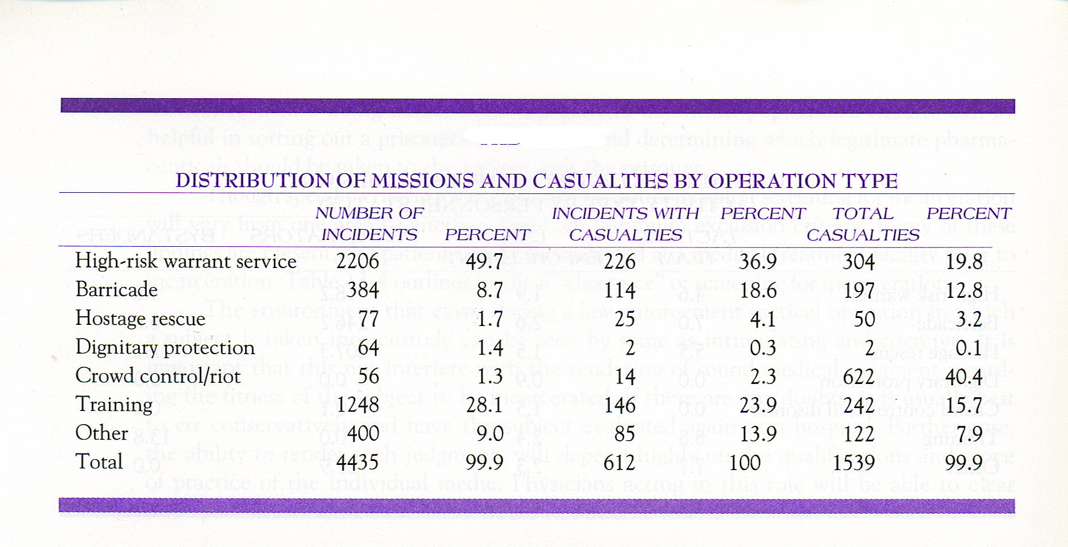
Figure 1.1
Taken from CONTOMS statistics, these figures show that
training exercises are the second leading cause of officer casualties.
Chapter
2
The History of TEMS
Though modern pre-hospital medicine is barely 30 years old, warriors have for millennia practiced one form or another of first aid to help ensure their victory on the battlefield.

The origins of battlefield medicine
When the Persian empire expanded west, only one thing stood between them and domination of Europe; the 300 elders of Sparta. These men held off tens-of-thousands of Persians in the battle of Thermopylae for several days. Each citizen-soldier had with him a shield-bearer or squire whose job it was to sharpen his sword, repair his armor and stitch his wounds. For this they carried catgut and gold needles, as well as herbal poultices to staunch bleeding.

In the 1600’s when Japan was in the midst of one of its many civil wars, thousand of samurai fought and died on Honshu. Among them were the Amma practicing their own form of battlefield medicine called taiso. Their only goal was to give a warrior a few more minutes in which to live in the service of his shogun.

The civil war saw the first use of ambulances and organized stretcher-bearers. Prior to the battle of Shiloh, General Sidney Albert Johnson’s surgeon, Dr. David Yandell, ordered that tourniquets be passed out to each soldier. During the course of the battle, General Johnson sustained a wound to his leg, severing the popliteal artery. He bled to death with his tourniquet still in his pocket.

EMS today
In 1966 the paper Accidental Death and Disability: The Neglected Disease of Modern Society was published. It outlined how rapid field interventions could dramatically increase the survival rates of critically injured patients. Within 11 years the national training standards for the EMT-Paramedic were in place.

In the early days of EMS, ambulance services often run by funeral homes. They provided no treatment--just a fast and dangerous ride to the hospital.

This evolution continues even today. Tactical EMS is the newest phase of pre-hospital medicine. Lessons taken from the special operations community have begun to be applied to law enforcement and SWAT operations. By training medics to work in the fluid tactical environment, life-threatening injuries can be treated immediately, thus ensuring the over-all safety of the team.

Tactical first aid
Tac1Aid is the little brother of tactical medicine. Simply put, Tac1Aid is field-expedient, life-saving first-aid with whatever means are at hand. It is quick and dirty and absolutely necessary for you, your partner, or even your family’s survival.

According to the Counter Narcotics Tactical Operations Medical Support (CONTOMS) statistics, casualty rates from high risk warrant service, training exercises, and hostage rescue can run as high as 10-30%.

Basic first aid saves lives. A FDNY study showed that patients treated with basic first aid and rapid transport to a trauma center had a higher long-term survivability than those whose care was delayed waiting for paramedics.

The Myths of Trauma
Chapter
3

KE = M x V²
2

The action genre of television and movies has perpetuated many inaccurate and even dangerous myths about traumatic injuries. From car wrecks to gunshots and edged weapons, the media has most often downplayed the debilitating nature of these types of injuries.

These myths follow through into ballistic trauma also. In shoot-outs with police, bad guys will often take five or more hits to the chest with little or no effect. While possible, this is unlikely. Even the smallest compromise of the thoracic cavity can lead to a tension pneumothorax or “sucking chest wound,” profound difficulty breathing, and eventually death.

“It’s the V2 that gets ya…” Velocity determines kinetic energy in trauma. More speed involved equals more damage sustained.
He’s only got a knife…
Knife wounds are portrayed often in the same light, being made to appear less deadly than they really are. In the hands of an expert, knives are definitely to be feared. The fatality rate of knife wounds can run as high as 27%, as compared to 25% for all pistol wounds. Knives are incredibly dangerous. They can easily sever veins, arteries, muscle, tendons, and ligaments in a single stroke. They have the ability to create an enormous wound tract and profound bleeding very quickly.

It should be mentioned that within their range, knives rarely miss, never jam, and never run out of ammunition. When properly employed, a four centimeter long knife blade can penetrate both the heart and lungs.

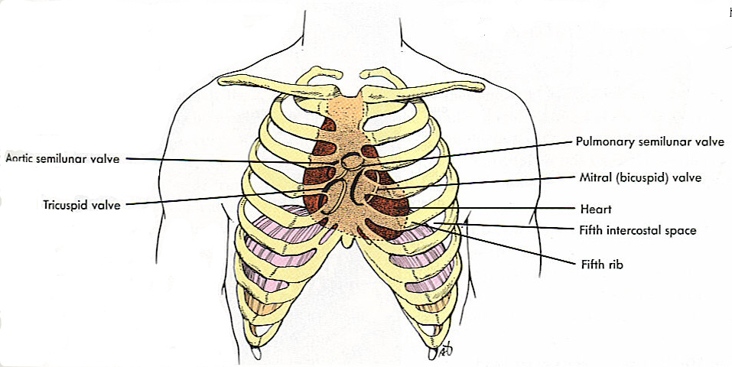

Figure 3.1
As you can see, there is not any “extra” room in the chest cavity.. The space not taken up by the heart and lungs is filled with veins, arteries, muscle, and other critical tissue.
Howdy, partner!
The cowboy western probably provides some of the best examples of how to not survive a traumatic encounter as any I can think of. Between cauterizing wounds, pulling out arrows or digging a Colt slug out of your leg with a Bowie knife, I am surprised anyone ever made it to the 20th century, let alone the 21st.

Wound cauterization is a staple of the old western in which a knife blade, branding iron, metal poker or just about anything else that would turn red-hot, was left in the fire then shoved into an open wound. There are a host of problems with this. The first is a very serious problem with infection, which can lead to fatal septicemia, or a system-wide infection with life-threatening effects. The swelling of the burn can cause a second long-term effect. It can actually clamp off blood vessels which are feeding the wounded area to help the healing process. This could lead to necrosis, or dead tissue, and the above-mentioned serious systemic infections. For most wounds cauterization is a poor choice over direct pressure or a tourniquet. If the bleeding is controllable then it needs to be dressed so that the body can form its own clean dressing: a clot. If it is uncontrolled then it needs to be treated with a hemostatic agent. If these agents are unavailable, use a tourniquet.
If it’s stuck…leave it!
Pulling out an impaled object, whether it be a knife, an arrow, or a table-leg is a bad idea. If it is stuck, you need to leave it in. Objects that are stuck in the body are putting pressure on severed blood vessels in the body and occluding them, or stopping them from bleeding. Pulling that object out releases the pressure and allows the bleeding to start up again. The same is doubly true for edged weapons such as swords, arrows or knives. Anything that cut going in will cut coming out. You could make the wound much worse by removing the object. It is much safer to try to immobilize it where it is until you’re able to see a doctor.

If there’s a hole…. plug it!
Another of the most common myths revolves around the “sucking chest wound.” This is the common term used for a tension pneumothorax. This occurs when the chest wall is compromised by some form of penetrating injury. The inside of your chest cavity is a vacuum. If the chest wall is pierced, the area of low pressure (the thoracic cavity) will seek to achieve balance with the area of high pressure (the outside environment). As the outside air is sucked into the chest cavity, the pressure collapses the lung on the side of the injury. As the condition progresses, the lung on the opposite side of the injury (assuming there is only one hole in the chest cavity) will also become compromised. Why is this a bad thing? Simply put, not breathing will kill you!

While the tension pneumothorax is fatal if untreated the facts are this:
1. In order to sustain a tension pneumothorax, you must have a hole in your chest 2/3 the diameter of your trachea (think of a roll of toilet paper).
2. The tension pneumothorax is easily recognized by the large hole, profuse bleeding, and red frothy bubbles.
3. An Asherman chest seal will dress the wound and relieve the pressure, allowing the lung to inflate properly.

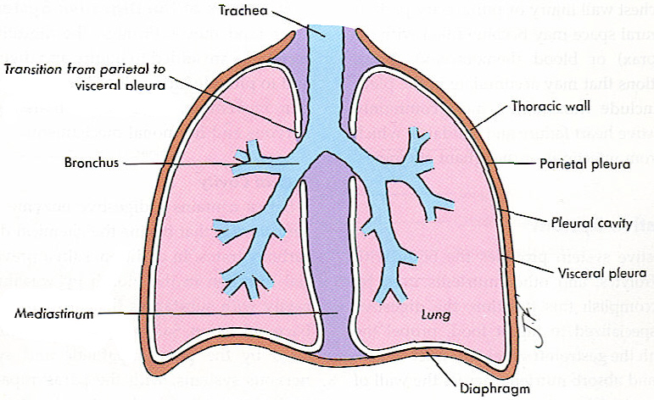
Figure 3.2
The lungs inflate by using negative pressure created by the diaphragm
Speed does not equal lethality
The last myth I’d like to cover is the common wisdom surrounding high-velocity ordinance and its higher rate of mortality. For years it was regarded as fact that high-velocity rounds such as the 5.56mm NATO round and the 7.62 Warsaw Pact round did a disproportionate amount of damage due to the effect of the cavitation. It was thought that the bullet’s high energy wave destroyed tissue all the way through the wound-tract and the surrounding area. Studies by the army have shown this not to be the case, and while the cavitation does indeed occur, there is no significant variance in battlefield mortality or long-term survival rates for soldiers with these injuries. Lethality is, however, increased through projectile deformity, multiple wound tracts, and fragmentation.

Figure 3.3
Due to the velocity of the projectile and the elasticity of the tissue, cavitation will cause a large temporary wound tract. This effect has no bearing on long term survivability.
The Truths of Trauma
Chapter
4

What is trauma?
Trauma: An injury caused by a transfer of energy from some outside source to the human body

T
he first truth about trauma is that it is the #1 cause of death from ages 1-44 years worldwide. This includes train wrecks, accidental falls, shootings and the occasional motor vehicle vs. moose. It is critical to begin trauma management within the first 10 minutes of the injury.

The truth about shock
Shock: inadequate tissue perfusion at the cellular level

Shock is one of those words that gets thrown around a lot. Any time someone is confused after a car accident they are said to be “going into shock”. This is not the case.

Shock is merely the lack of oxygen in the tissues of your body. At the end of your life, as your body uses up the last of the available oxygen, you go into shock. There are many kinds of shock but in this venue we are mainly concerned with hemorrhagic shock.

Hemorrhagic shock is lack of circulating oxygen due to blood loss. Since blood carries oxygen, the less blood in the body, the less circulating oxygen. The three stages of hemorrhagic shock are:

- Compensated Shock
- Uncompensated Shock
- Irreversible Shock

Compensated shock occurs when tissue perfusion decreases, but the bodies homeostatic mechanisms go into effect. Increased blood pressure, heart rate, and respiration counter-act the lower oxygenation to maintain normal function. Compensated shock is reversible.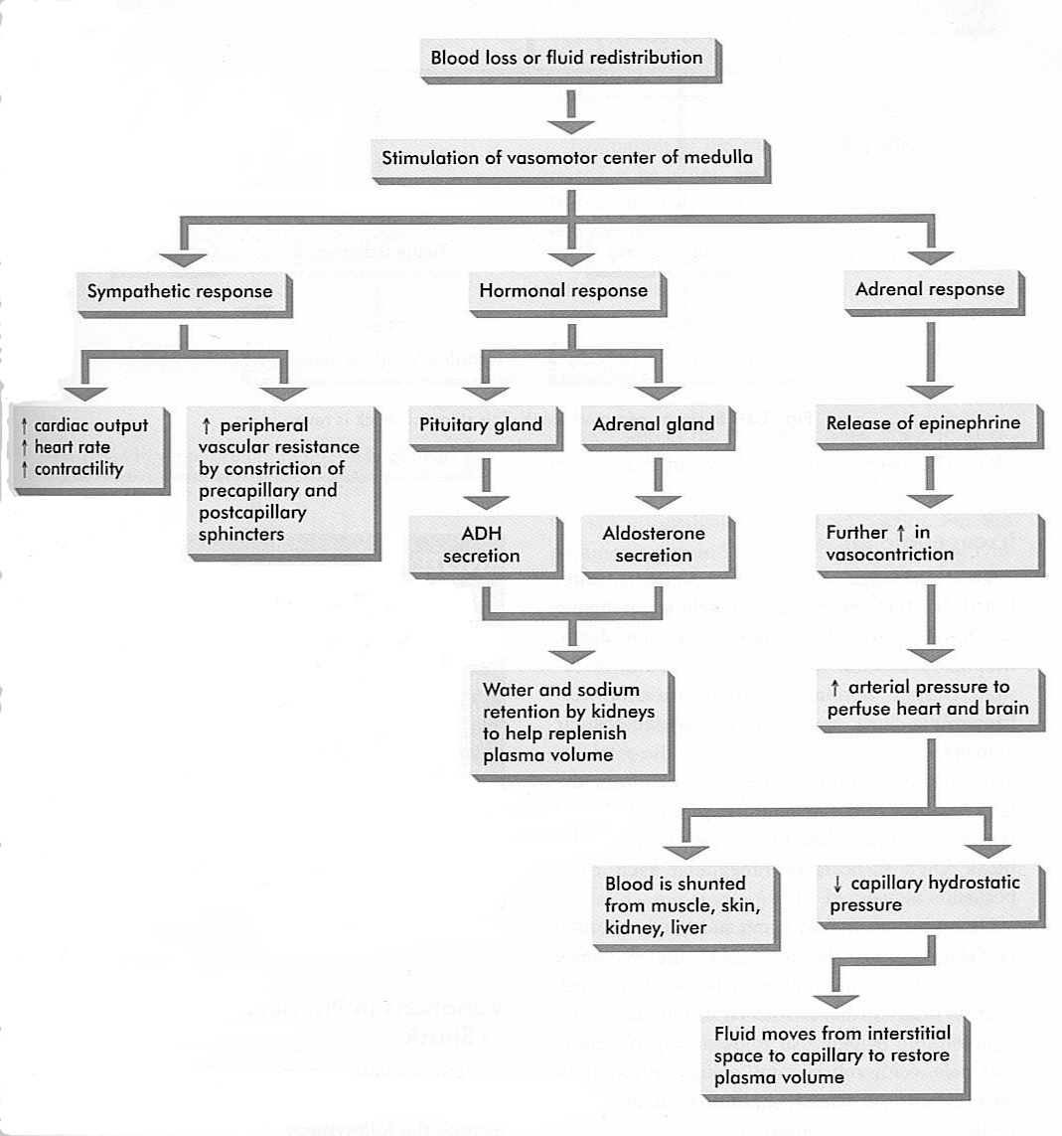

Figure 4.1 Compensated shock.
Pay special attention to the far left and far right branches of the flow chart.

Uncompensated shock sets in after your body has ceased to compensate. Blood pressure drops, heart rate increases, as does respiration. All blood is shunted from the extremities to the core of the body, the heart and brain. Mental acuity fails. This stage of shock is also reversible.
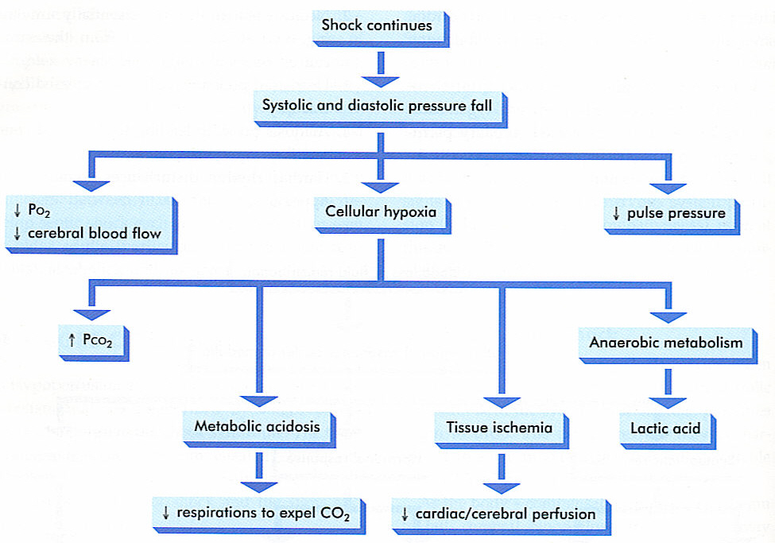

Figure 4.2 Uncompensated shock:
the slippery slope

Irreversible shock is marked by a slow heart rate and respiration, massive organ failure and eventually death. This can occur suddenly or up to 1-3 weeks after the insult. Once the disease process has progressed to this stage, the outcome is unavoidable.

The goal of this class is to avoid shock at all costs. We do this by providing rapid intervention for traumatic injuries.

The truth about blood loss
MV=SV x HR
Uncontrolled extremity hemorrhage is the number one preventable cause of death on the battlefield. The most effective treatment for it is a tourniquet. This statistic has not changed since the civil war. New advances in medical technology are seeking to address this problem. One of the most promising though constantly evolving methods of hemorrhage control is the use of Hemostatic Powders like Celox.

At a heart rate of 100 beats per minute, your heart pumps roughly 80 cc’s of blood per contraction. The average adult male has 7 liters or 12 pints of blood. If you were to suffer a severe and uncontrolled hemorrhage, you could conceivably lose your entire circulating volume of blood in less than a minute.

Estimating blood loss
Learning how to assess exactly how much blood you or a victim has lost is very important. It can be an excellent gauge of how severe a wound really is.

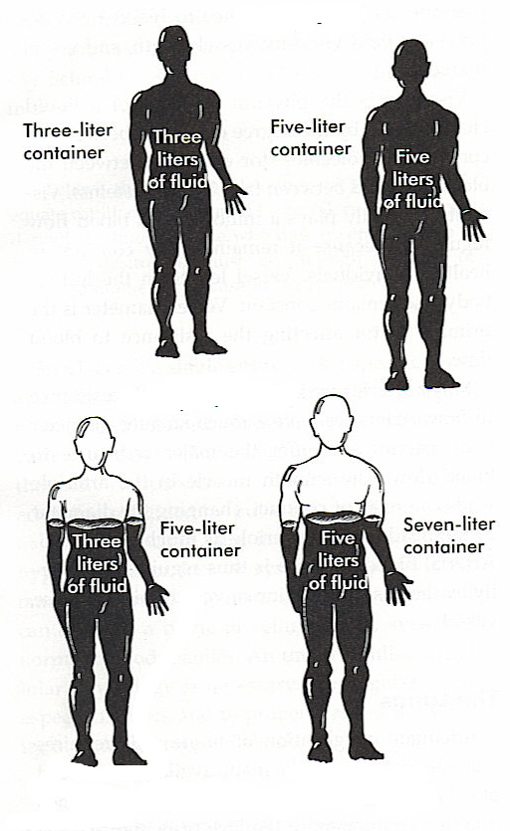

Figure 4.3
Make sure your container stays full!

An adult male hold roughly 7 liters or 12 pints of blood. A patient can lose 4 or 5 liters of blood and survive, provided they are transfused with replacement almost immediately. This would already have put the victim into uncompensated shock, but with definitive care (treatment in a trauma center) it could be reversed.
Overt blood loss
The following is a list of items and the rough amount of fluid they can soak.

1 Sock | 50ML’s
Dishtowel | 500 ML’s
T-Shirt | 750ML’s
Long Sleeve Shirt | 750-1000ML’s
Long Pants | 1500 ML’s

By observing the amount of blood soaked into clothing, you can make an educated guess about the extent of the blood lost. The amount of blood seen, however, does not tell the whole story. The blood that you see on the outside is the overt, or obvious, blood loss. Bleeding that occurs inside the body will be hidden from plain view, but it is just as deadly.

Occult blood loss
Occult blood loss will most often be seen in penetrating injuries to the abdomen or thorax. While there is no treatment in the field for these injuries, it is an important concept to understand.

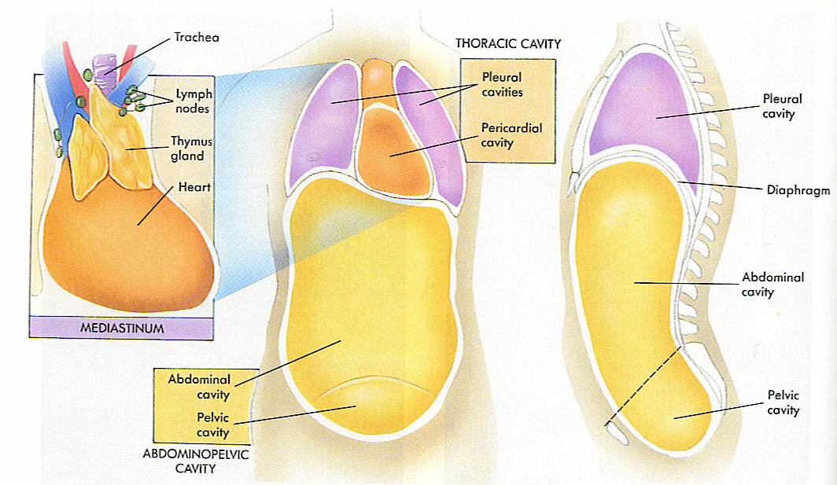

Space and potential space
Inside your body there are many open spaces where blood can accumulate. Most of those spaces will be hollow organs, such as the stomach, large and small intestine, and the bladder. Potential spaces include the areas between the heart and the pericardium, or between the visceral and parietal pleura. Under normal circumstances, this tissue will be in close contact to each other. However, if an injury were to introduce blood in between those surfaces, they would be pushed apart, creating an area for blood to flow into.

Bladder | 500cc
Thigh | 1000cc
Stomach | 2000CC
Abdominal Cavity | 7000cc

The pneumothorax
The second leading cause of preventable death on the battlefield is the tension pneumothorax, or sucking chest wound.

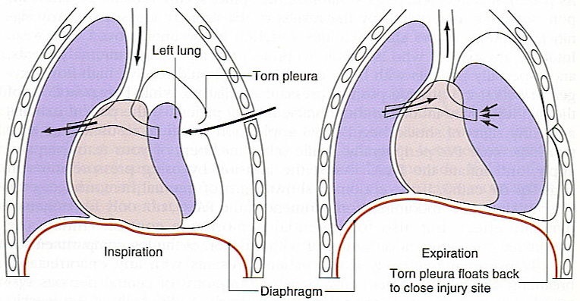

A tension pneumothorax is caused when the exterior envelope of the chest, or thorax, is penetrated. This penetration causes the loss of the vacuum that makes respiration work. As air spills into the cavity, the lung on the affected side collapses. As the condition progresses, the heart and eventually the lung on the unaffected side will also become affected. In the late stages of a sucking chest wound, you will begin to see the trachea pull away from the affected side. This is however a very late sign and the condition must be treated before this happens.

Tension pneumothorax:

penetrating chest trauma
+
increasing respiratory distress
=
sucking chest wound

There are two other forms of pneumothorax, which I will touch upon briefly though there is no method of treatment within the scope of Tac1Aid.
A simple pneumothorax, sometimes called the paper bag syndrome, often occurs when a victim of a motor vehicle collision holds there breath before hitting the steering wheel. Just like when you blow up a paper bag, the air has nowhere to go and the lung or lungs will pop. This lets air into the thoracic cavity and just like with a tension pneumothorax, the lung collapses and profound difficulty breathing follows.

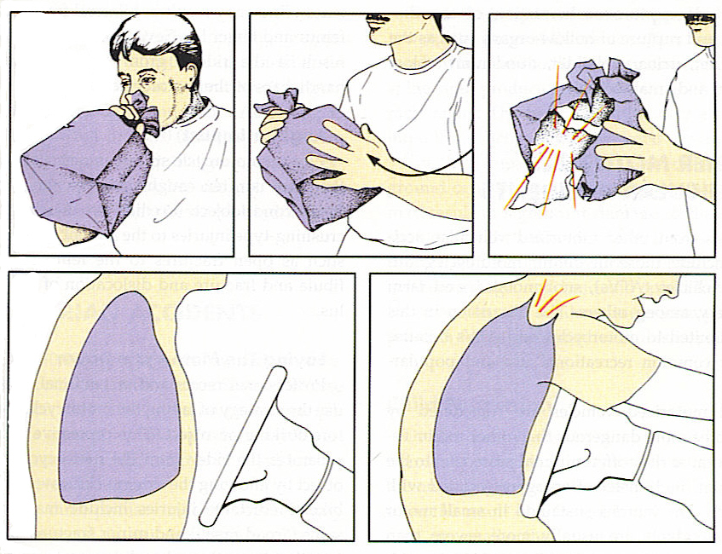

Officers wearing ballistic vests are at a greatly reduced risk for simple pneumothorax as well as traumatic cardiac arrest when involved in MVCs.
A hemothorax is caused when blood, not air, begins to fill the thoracic cavity. This too will eventually collapse the lung and cause profound difficulty breathing. Because every rib in your chest has a nerve, artery, and vein bundled to the underside of it, intra-thoracic hemorrhage is not an unlikely outcome to a penetrating injury.

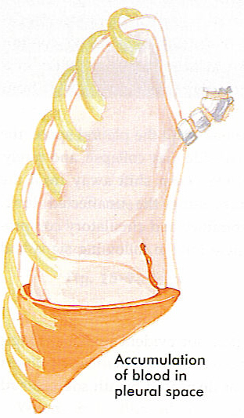
Interestingly enough, the preferred treatment for either of these conditions is to induce an open pneumothorax by inserting a large-bore IV catheter with a one-way valve into the chest and releasing the pressure. After doing so a rush of air or blood will be observed. This is however beyond the scope of our practice at the Tac1Aid level.

Lies, Damn Lies, and Statistics

There has always been a good deal of controversy over the lethality of certain types of ordinance and blade configurations.

Shotguns | 34%
Pistols | 25%
Rifle | 24%
Unknown GSW | 55%
All GSW | 23%
Butchers Knife | 38%
Folding Knives | 27%
Ice pick | 40%
All Stab Wounds | 10%

Most people fail to realize exactly how lethal a knife really is. In the above table, taken from the Annals of Surgery #179, pp 673, folding knives have an equivalent lethality to handguns. Let’s look at the following facts:
- In the UK, edged weapon assaults account for 7 out of 20 murders
- According to the FBI, 10% GSW victims die, 30% of edged weapon victims die.
- The typical depth of a fatal stab wound is 1.0-1.5 inches
- 85% of police officers cut with a knife never saw the blade and did not know they had been cut until after the suspect was in custody.
- A knife with a 5” blade can create a 30” laceration, and a puncture wound of 12+ square inches.
The Theory and Practice of Tac1Aid
Chapter
5
“What’s the difference between bad medicine and bad tactics? You can survive bad medicine….”
- Anonymous 18-D operator
It is impractical to train for every possible injury and every possible tactical scenario that may occur. Does that mean you shouldn’t train at all? Of course not. Military doctrine trains for the five most likely scenarios. In our practice this will include: gunshot wounds to the abdomen, thorax, or an extremity, as well as knife wounds to include lacerations and impalements. All of the above will be treated with a combination of direct pressure, hemostatic agents, and bandaging.

This class focuses on treating the two most lethal and preventable causes of battlefield deaths: uncontrolled extremity hemorrhage and the undiagnosed sucking chest wound. Both of these conditions should be addressed in the tactical medicine phase of Tac1Aid. The treatment of these wounds is labor intensive and generally requires two hands and therefore cannot be addressed while engaging a target.

The death of General Albert Sidney Johnson
General Sydney Albert Johnson was a top confederate officer. Prior to the battle of Shiloh, General Johnson’s surgeon, Dr. David Yandell, ordered that tourniquets be passed out to each soldier. During the course of the battle, General Johnson sustained a wound to his leg, severing the popliteal artery. He bled to death with his tourniquet still in his pocket. Since the civil war, very little has changed in platoon level battlefield care. The use of bandaging and tourniquets is still standard practice. This class will introduce the most modern advances in bleeding control: hemostatic agents including Celox.

CPR under fire

CPR has little to no effect on patients suffering from a traumatic cardiac arrest. In a study conducted by the army, 138 soldiers received CPR after cardiac arrest due to trauma. There were no survivors. In a tactical scenario there are only two possible outcomes to CPR:

1. Rescuer might get killed.
2. Victim will stay dead.
The Exception to the rule

In the civilian world of EMS, a traumatic arrest (lack of a pulse due to injuries sustained) has a 1% chance of survival. Thus, there are a very limited number of exceptions where CPR will be performed on a patient. For our purposes these will be limited to situations where there is no threat present WHAT SO EVER. Such as when the suspect is in custody or an accidental discharge where there is no tactical threat.

In the military or SWAT setting, CPR will only be initiated if the mission parameters allow sufficient resources to be dedicated to the resuscitative effort. This will include up to three Medics and four litter-bearers.

Spinal immobilization
It is tactically infeasible to properly immobilize a possible spinal patient under fire. It takes 5.5 minutes for three rescuers to properly immobilize one casualty. In Vietnam less than 1% of soldiers suffering from penetrating neck trauma would have benefited from full spinal immobilization. You have to weigh a 1% benefit versus the risk to the casualty and the rescuer or rescuers.

Tourniquets

When using tourniquets, there are a few basic rules to keep in mind:

1: Tourniquets should be applied prior to the use of a hemostatic powder, or when one is not available. The reduction in blood flow caused by the tourniquet will improve the chances of the HP stopping the bleeding.

2: They must be at least 1” wide. Any narrower than that and they can cause more damage to the underlying tissue.

3: Tourniquets should be applied on the side of the wound closest to the body, but below the next joint up the limb.

4: Tourniquets should never be applied during the care under fire phase. They take too long to apply and require two hands to place effectively.

The practice of Tac1Aid

Tactical first aid can be broken down into three distinct phases.

Phase One: Care Under Fire

Control bleeding, shoot back

Care under fire is delivered at the scene of the injury while still under fire. It should be limited to controlling major bleeding while attempting to gain fire-superiority. Your primary concern is not getting shot, finding cover, and then the treatment of the casualty. While still actively engaged with a hostile enemy, it is paramount to be able to return fire. This prohibits complicated interventions such as IV’s and tourniquets. What does returning fire have to do with first aid?

THE BEST MEDICINE ON THE BATTLEFIELD IS FIRE SUPERIORITY

The Toohey Amendment

“I also expect the casualties to continue to return fire as long as they are able to do so.”
--CDR Pat Toohey, commanding officer, SEAL Team Four

If the medic or rescuer gets shot while performing their interventions, then no one gets help.

During the care under fire phase of care, all you are concerned with is breathing and hemorrhage. In EMS this is called the primary survey, or the ABC’s (Airway, Breathing and Circulation).

The primary survey
The Primary Survey consists of checking the airway, breathing and circulation, or the ABC’s. For Tac1Aid, we reverse that thusly:

1) Control bleeding (circulation)

2) Asses respiration (are they breathing?)

3) Reposition the airway (if no breathing)

Phase Two: Tactical medicine

Nose to toes, treat as you go

The tactical phase of Tac1Aid (aka ditch medicine) starts when you either gain fire superiority, find adequate cover, or neutralize the immediate threat. In this phase you are looking to:

    - Conduct your secondary survey

    - Control all major and minor bleeding

    - Treat any possible pneumothorax

    - Prepare for casualty evacuation.

The Secondary Survey begins with the ABC’s (for us, CBA’s) and then moves into a head-toe physical exam. You will expose any are of the body that has a potential injury. During the head to toe, you will stop and treat any injuries you find.

Phase Three: Combat Casualty Evacuation

Throw and go, or stay and play?

Casualty evacuation begins when either EMS arrives or you decide to transport a victim on your own. It is important to consider the extent of the victim’s injuries, the response time of EMS, and how close you are to a hospital. There are serious implications and possible adverse outcomes to either course of action. They should be weighed carefully.

If bleeding has been controlled, victims should be transported head down, feet up in the crash position.
The Treatment of Trauma
Chapter
6

There is an old expression in EMS that trauma is plumbing, which is basically true. Your circulatory system is essentially made up of three parts, the pump, the pipe, and the fluid, or the heart, blood vessels and blood, respectively. If any one of these parts fails, then the system will fail along with it.
At our level of practice, trauma management will consist of plugging the holes in the circulatory system. We’ll do this in three ways.

First will be the use of bandaging. Bandaging consists of applying direct pressure to a wound site with some form of dressing that will absorb the blood, and apply pressure to the wound, facilitating clotting. Bandages should be secured with a pressure dressing to ensure the wound is kept clean and bleeding is kept under control.
If direct pressure fails to control bleeding then you will then graduate to the use of Tourniquets. Tourniquets should be applied on the side of the injury closest to the body (upstream) but below the next joint. This is to ensure that the least amount of tissue will be denied oxygen.
When the tourniquet is applied, it is important that it be at least 1-inch wide, and only tightened enough so that the bleeding is controlled. At our level of practice, once a tourniquet is applied it should not be removed. Transport to a trauma center is critical for the victim, since prolonged application of the tourniquet can cause massive amounts of tissue damage and lead to the amputation of the limb. As serious as this is, it is not as bad as dying from the uncontrolled bleeding.

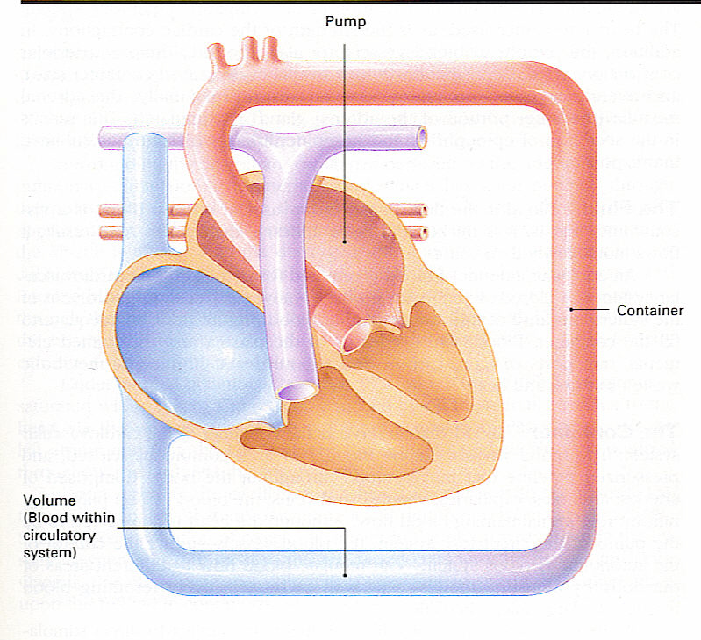
Figure 6.1
The “plumbers triad”: pump, pipes, and fluid

The final options in uncontrolled bleeding from an extremity wound are hemostatic powders and hemostatic gauze. Even if the tourniquet fails to completely stop the bleeding, the pressure of the blood flow will be reduced. Agents like the QucikClot Combat Gauze or Celox granulated powder are much more likely to work in that low-pressure environment.
All brands of hemostatic powders and dressings work through different chemical action. It’s important you are familiar with the manufacturer’s specific warnings on usage though hemostatic agents have a few general rules:
- Stay away from the eyes.
- Use only on the extremities! No belly, back, chest, or neck wounds.
- Soak up as much blood from the wound as possible before application.
- Apply direct pressure after you use the hemostatic agent. Keep the site clean and dry.

Next Generation Trauma Medicine: The Bloodless Battlefield
Chapter
7
From the civil war to the gulf war, there was one consistent fact in battlefield medicine: of the casualties not killed outright, most would die from uncontrolled bleeding to an extremity. The medical field evolves relentlessly while teams of researchers all over the world compete to field new products and procedures that will improve the outcome for victims of trauma. From powders that control arterial bleeding to IV solutions that will carry oxygen, these advances will change the face of combat medicine. As with most fields of research there are many dead ends and false starts before you find that perfect balance you’re looking for.

For years surgeons, nurses and the boxing ring’s “cut man” have used various medications to control bleeding. One of the most common is epinephrine, or synthetic adrenaline. In boxing it is used to control bleeding, especially above the eye, which would obscure the boxer’s vision and possibly cost him the fight. Adrenaline causes vasoconstriction, or the tightening of veins and arteries. While it is effective on small cuts, it is not appropriate for the treatment of knife or gunshot wounds. In 1998 the United State Special Operations Command (USSOCOM) put out to bid a contract to develop a hemostatic powder to deal with his problem. The parameters of the contract stated that it had to be able to stop arterial bleeding, have a long shelf life, and had to be “soldier proof.”

When I was training as a paramedic at the University of Texas Health Science Center in San Antonio, I was in close contact with many of the army’s 18-Delta operators. These Special Forces medics train for over two years in every aspect of medicine, from trauma management to dentistry. Overseas, they are the Doc.

While talking with these consummate trauma medics, I was told about a new powder that was being tested which would totally stop arterial bleeding in a wounded soldier. One medic, while training in advanced trauma life support at Bethesda hospital, participated in a demonstration where a live goat was shot in the thigh to approximate a complex groin injury, which is common in battlefield medicine.

“It was amazing,” he told me. “After applying direct pressure to the wound, they dumped this powder into the cavity and continued to apply pressure…. and the bleeding just stopped!”

I was intrigued and wanted to know more, but at the time these products were not FDA approved. Several years later, there were two products on the market as a result of the SOCOM study; TraumaDex and QuickClot. These hemostatic agents greatly reduced the chance of a soldier or officer dying from blood loss but each had its own limitations and drawbacks. The Z-Medica product Quick Clot has been shown to stop arterial bleeding 100% of the time within 30 seconds but produced an unacceptable exothermic reaction that caused burns. The current hemostatic agents used in theatre are Celox granulated powder and QuickClot Combat Gauze. Neither of these causes burns and the Celox will work even on blood that has been “thinned” by medications like Heparin.
Reports from Afghanistan and Iraq are promising. Hemostatic powders have performed remarkably well, and according to sources in-theatre, saved a lot of lives. There is no reason to suspect that the results at home won’t be just as remarkable. As the use of hemostatic powders becomes more wide spread in the civilian world, EMS and the police will be able to treat wounds immediately on-scene that otherwise could have proven fatal.

The next step in trauma management in the field is the hemostatic dressing, or HD as it is referred to by its developers. The research in this area was also prompted by SOCOM, who wanted to see the advances in hemostatic powders applied to bandages and pressure dressings, the standard load for all combat medics. To date there have been several successful products developed and at the time of this printing, and a few of them have cleared FDA trials. One of which is the QuickClot Combat Gauze, and Celox has its own version of hemostatic gauze.

One of the most promising HD’s uses a chemical compound called chitosin as its main ingredient. This chemical is a derivative of shrimp shells, and not only does it work to stop massive bleeding, it is also a natural antimicrobial agent, and helps prevent infections! Some other HD’s are using fibrinogin from trout and even bovine lung polypeptide extracted from cows.

Every field of endeavor has its Holy Grail, and for the trauma medic it is an IV fluid that carries oxygen. There are several choices of fluids when starting IV’s, but for combat operations, Hespan seems to be the gold standard. It has a disproportional benefit as a volume expander as compared to normal saline, which is the most common fluid in civilian applications.

When a medic starts and IV on a patient and delivers a fluid bolus of one liter to compensate for blood loss, only 200 ml’s will remain in the blood stream after 1 hour. That means you lose 80% of the fluids ability to keep your blood pressure elevated. On the other hand when you administer one liter of Hespan, six hours later you will have 1600 ml’s of fluid still in the blood stream! This is a 60% gain in volume expansion, and when you have to carry everything you use…that’s a big benefit.

As wonderful as Hespan is, it is still strictly a volume expander. Giving it in trauma will simply help the body elevate your blood pressure. There is not one IV fluid on the market today which carries oxygen. Lack of oxygen causes shock, and shock kills you. Several companies, including Northfield Labs and Biopure are working on an HBOC, or hemoglobin based oxygen carrier. It is conceivable that in the near future, civilian and military medics will be carrying IV Fluids that, like Hespan, almost double their own volume in expansion, and carry oxygen more efficiently than your own blood.

The lifesaving benefits of these advances will be astronomical.

Tactical Patient Movement
Chapter
8
In medicine, the extrication, packaging, and transport of injured persons is the sole realm of the paramedic. It is by far more art than science, developed after 30 years of practicing techniques that are expedient and safe for the patient.

Some of the basic concerns when moving an injured person include the safety and ergonomics of the rescuer, field expedience, and maintaining the safety of the victim. The cardinal rule for rescuers is do no harm. When you add the dynamic of working in a tactical environment, you must also consider the inherent dangers of your area of operations, the safety of the rescuer, and the ability to take direct action against hostile aggressors. All methods of carry and movement should be safe for both the rescuer and the victim.

The following gallery shows several of the accepted civilian methods of moving an injured person.

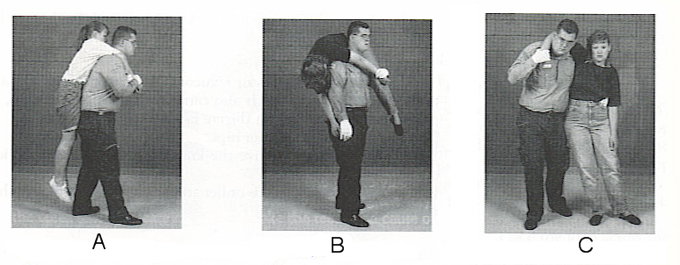

- The Pack Carry
- The Fireman’s Carry
- The Supported Carry

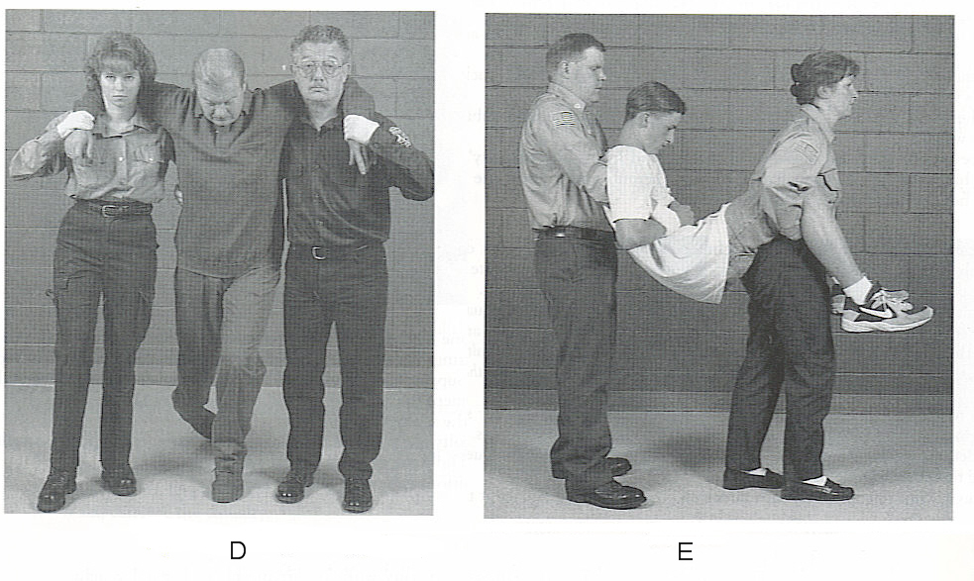
- The 2 Person Support Carry
- The Fore and Aft 2 Man Carry

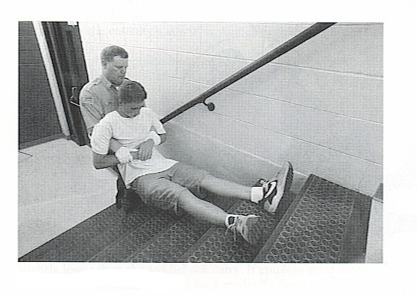
- The Rear Drag

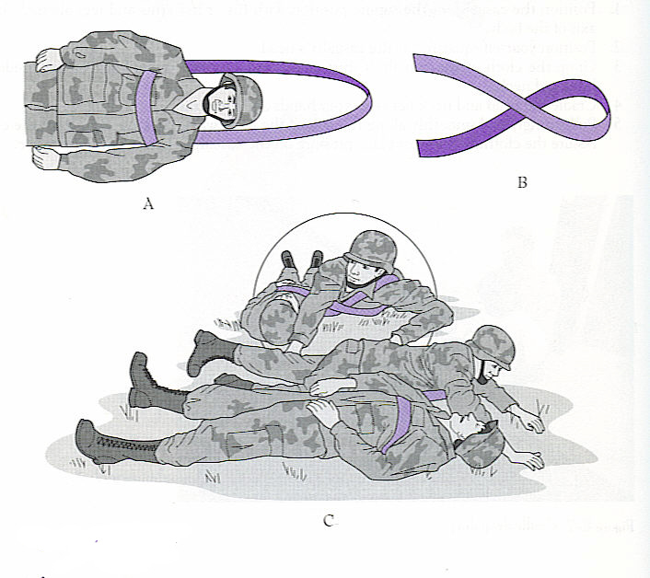
- The Sling Drag

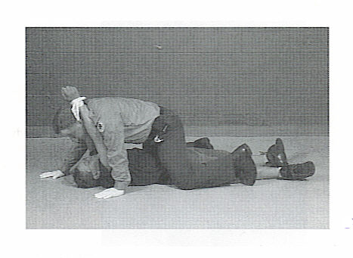
- The Turtle

Any method of carry should allow the rescuer to remain tactically aware and ready to fight. You should be able to maintain control and access to your weapon, and your ability to engage any threat as it arises.

