Energy Balancing
FOUNDATION Fieldbus Vortex Meters for Liquids, Gas, and Steam
Versatile Flowmeters
Steam, gas, and liquids play an important role in all industrial processes. To reduce costs and optimise production, their consumption, storage and demand have to be constantly monitored and controlled. Vortex meters are very suitable for such tasks, being easily assembled, reliable, accurate, and suitable for almost any fluid. When sized correctly, vortex meters will provide a linear output, low pressure loss and high accuracy. The meters' installation and maintenance are straightforward. As a result, vortex meters are finding increasing use in applications formally covered by DP cells and orifice plates. Versions with an integrated temperature sensor render additional sensors and calculator units to balance the energy of saturated steam superfluous for many applications.
Endress+Hauser PROline Prowirl 72 and 73 now offer these advantages to the FOUNDATION Fieldbus user. This new generation is highly resistant, works reliably under the harshest of conditions and offers additional analog outputs, such as saturated steam mass.

Innovative Measurement
Vortex flowmeters use the phenomenon of the von Kármán vortex street, see Fig. 1. When a fluid flows against a bluff body in a pipe, the layers of the fluid near the body cannot follow its contours. They separate from its surface and form vortices that are shed alternatively from either side and swept downstream with the fluid. The number of vortices shed per unit time is a measure of flow rate.
The “heart” of the new Prowirl meters is the patented capacitive DSC™ sensor, already proven in more than 100,000 installations worldwide. Similar to a flag, the sensor paddle projecting into the pipe is deflected by the vortex generated at the bluff body-- this changes the distance between the central electrode and the outer electrodes, and thus the capacitance of the sensing system. The device electronics count the capacitance oscillations, from which the flow rate is calculated.

Reliable and Accurate
This procedure is reliable and accurate. The maximum measured error is ±1% of the instantaneous value for gases and steam and ±0.75% for liquids. For gases, flow rates of up to 250 ft/s may be detected; in the case of liquids the maximum flow rate is 30 ft/s. Turndowns of up to 40:1 are possible: i.e. the flowmeter can be set-up to measure across a range that is 1/40th of its nominal rating.
Thanks to well-balanced mechanics, measurements are not affected by vibrations from, e.g., pumps or compressors nor do clogging media create problems because, e.g., rust particles do not affect the function of the sensor paddle. The sensor is highly resistant to water or steam hammer and extreme temperature shocks present no problems.

Rugged
Prowirl vortex meters are made of stainless steel or C-22 alloy. They are suitable for process temperatures between –40 °F and +500 °F. High-and low temperature versions handle temperatures between –330 °F and 750 °F. For high-pressure applications, sensors can be equipped with an additional secondary containment. All devices are approved for hazardous zones FM/CSA Cl. I/II/III, Div. 1/2 and ATEX Zones 1 and 2, special versions are approved for Zone 0 or dual rated for dust and gas zones (II 1/2GD).

Saturated Steam Mass
When used to measure steam mass, vortex meters are often combined with a pressure and/or temperature sensor and a calculator unit. The PROline Prowirl 73 now measures saturated steam mass without the need for such auxiliary equipment. A temperature sensor integrated into the sensor paddle provides in-line measurement. As there is a defined relationship between temperature and pressure, saturated steam mass can be calculated and is provided directly as a analog output value.
Since the auxiliary equipment is no longer required, investment costs and expenditure is significantly reduced. In addition to the application for saturated steam, liquids such as thermo-oils and water can be measured.
Superheated steam or Gases (e.g., natural gas, compressed air) can be measured assuming a constant pressure or providing pressure as an Analog Output from the bus side.

Figures

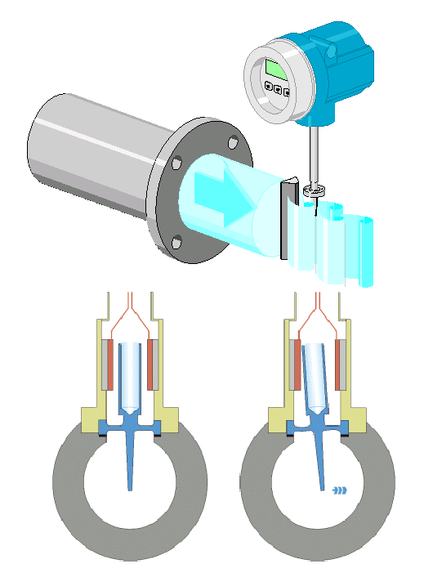
Fig. 1: The patented capacitive vortex counter is placed behind the bluff body. If the paddle projecting into the pipe is deflected by a vortex, the position of the centre electrode changes as well. The balanced system is resistant to vibration and works reliably even after suffering extreme temperature shock. [V0039] [V0038]

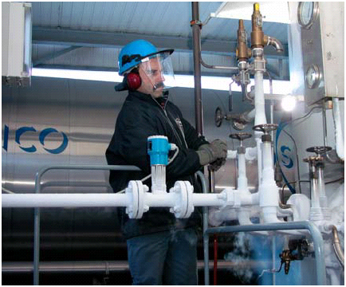
Fig. 2: High or low-temperature versions handle temperatures from –200 °C to + 400 °C . In this case the Prowirl is operating at about –200 °C in a liquid nitrogen filling station. [DSCN0014]
