The Basics of Predictive / Preventive Maintenance
Maintenance costs, as defined by normal plant accounting procedures, are normally a major portion of the total operating costs in most plants. Traditional maintenance costs (i.e. labor and material) in the U. S. have escalated at a tremendous rate over the past 10 years. In 1981, domestic plants spent more than $600 Billion to maintain their critical plant systems. By 1991, the costs had increased to more than $800 Billion and topped $1.2 Trillion in 2000. These evaluations indicate that between one third and one half of these maintenance dollars are wasted through ineffective maintenance management methods. American industry can no longer absorb this incredible level of inefficiency and hope to compete in the world market. Similar data for other countries is scarce, but we believe the situation is pretty much the same.
The dominant reason for this ineffective use of maintenance expenditures is the lack of factual data that quantifies when and what kind of maintenance is needed to maintain, repair or replace critical machinery, equipment and systems within a plant or facility. Typically, maintenance organizations do not track equipment performance, maintenance tasks performed, failure history or any of the other data that could, and should, be used to plan and schedule tasks that would prevent premature failures, extend the useful life of critical plant assets and reduce their life cycle cost. Instead, maintenance scheduling has been, and in many instances, still is determined by equipment failures or on the perceptions of maintenance personnel who arbitrarily determine the type and frequency of routine maintenance. For example, most facilities that employ thermographic inspections have it done once a year or every 6 months. This is a purely arbitrary decision, not supported by any kind of factual data.
In addition, middle and corporate level management has ignored the impact of the maintenance operation on product quality, overall operating costs and more importantly on bottom-line profit. The general opinion has been "Maintenance is a necessary evil" or "Nothing can be done to improve maintenance costs". Perhaps these were true statements 10 or 20 years ago. However, the development of microprocessor or computer-based instrumentation and maintenance management systems provide the means to optimize maintenance effectiveness.
Microprocessor-based instrumentation, such as infrared monitoring and vibration devices, can be used to monitor the operating condition of critical plant equipment, machinery and systems. The knowledge gained from these instruments provides the means to effectively manage the maintenance operation. As a minimum, they provide the means to reduce or eliminate unnecessary repairs, prevent catastrophic machine failures, and reduce the negative impact of ineffective maintenance operation on the profitability of manufacturing and production plants. When their full capability is used, these instruments provide the means to optimize total plant performance, useful equipment life, and life cycle costs of the facility and its assets. Computer-based maintenance management systems provide the historical data and means to use the data derived from predictive maintenance technologies, such as infrared monitoring and vibration.
Industrial and processing plants typically use two types of maintenance management, either run-to-failure or preventive maintenance.

Run-to-Failure Management
The logic of run-to-failure management is simple and straightforward. When a machine breaks down … fix it. This "If it ain't broke, don't fix it" method of maintaining plant machinery has been a major part of plant maintenance operations since the first manufacturing plant was built and on the surface sounds reasonable. A plant using run-to-failure management does not spend any money on maintenance until a machine or system fails to operate. Run-to-failure is a reactive management technique that waits for machine or equipment failure before any maintenance action is taken. It is in true a no-maintenance approach of management. It is also the most expensive method of maintenance management.
However, it should be said that few plants use a true run-to-failure management philosophy. In almost all instances, plants perform basic preventive tasks, i.e., lubrication, machine adjustments, and other adjustments, even in a run-to-failure environment. However in this type of management, machines and other plant equipment are not rebuilt nor are any major repairs made until the equipment fails to operate.
The major expenses associated with this type of maintenance management are:
- High spare parts inventory cost;
- High overtime labor costs;
- High machine downtime and
- Low production availability.
Since there is no attempt to anticipate maintenance requirements, a plant that uses true run-to-failure management must be able to react to all possible failures within the plant. This reactive method of management forces the maintenance department to maintain extensive spare parts inventories that include spare machines or at least all major components for all critical equipment in the plant. The alternative is to rely on equipment vendors that can provide immediate delivery of all required spare parts. Even if the latter is possible, premiums for expedited delivery substantially increase the costs of repair parts and downtime required to correct machine failures. To minimize the impact on production created by unexpected machine failures, maintenance personnel must also be able to react immediately to all machine failures.
The net result of this reactive type of maintenance management is higher maintenance cost and lower availability of process machinery. Analysis of maintenance costs indicate that a repair performed in the reactive or run-to-failure mode will average about three times higher than the same repair made within a scheduled or preventive mode. Scheduling the repair provides the ability to minimize the repair time and associated labor costs. It also provides the means of reducing the negative impact of expedited shipments and lost production.

Preventive Maintenance
There are many definitions of preventive maintenance, but all these management programs are time-driven. In other words, maintenance tasks are based on elapsed time or hours of operation that are based on statistical or historical data for specific types of plant equipment. Figure 1.1 illustrates an example of the statistical life of a machine-train. The mean-time-to-failure (MTTF) or bathtub curve indicates that a new machine has a high probability of failure during the first few hours or weeks of operation, usually caused by manufacturing or installation problems. Following this initial period, the probability of failure is relatively low for an extended period of time. Following this normal machine life period, the probability of failure increases sharply with elapsed time or hours of operation. In preventive maintenance management, machine inspections, lubrication, repairs or rebuilds are scheduled based on the MTTF statistic.
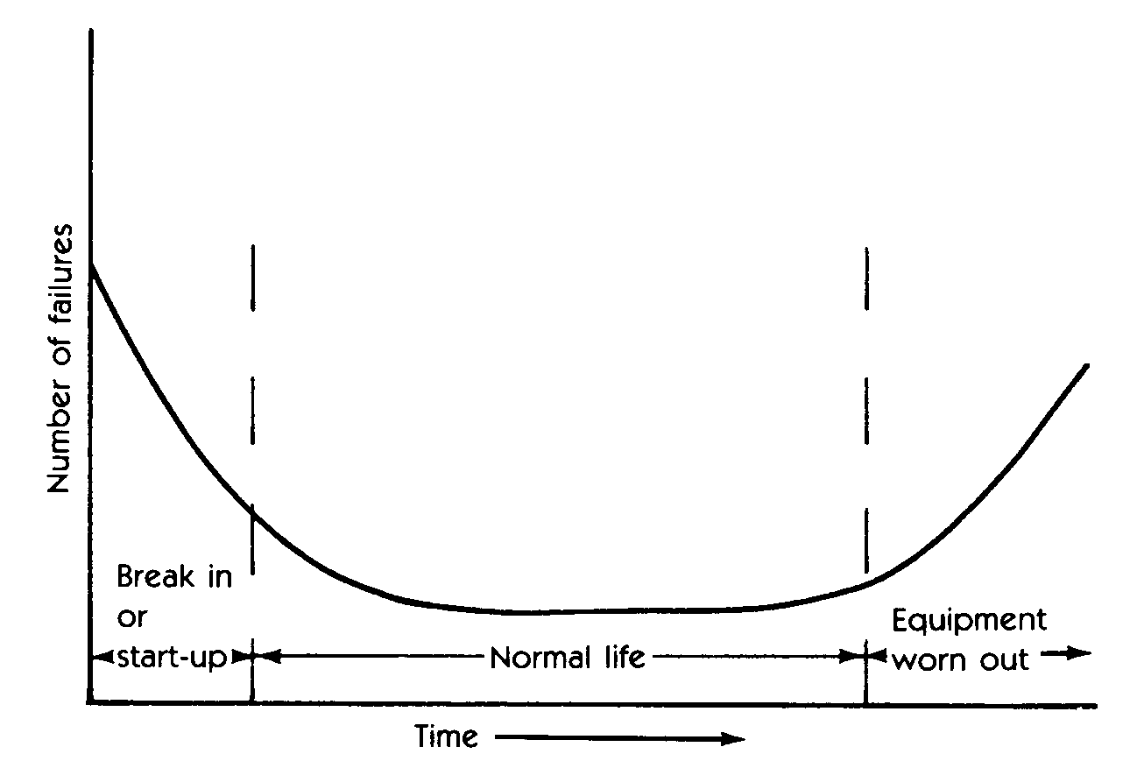
- Bathtub curve.
The actual implementation of preventive maintenance varies greatly. Some programs are extremely limited and consist of lubrication and minor adjustments. More comprehensive preventive maintenance programs schedule repairs, lubrication, adjustments and machine rebuilds for all critical machinery in the plant. The common denominator for all of these preventive maintenance programs is the scheduling guideline. All preventive maintenance management programs assume that machines will degrade within the statistical time frame typical for its particular classification. For example, a single-stage, horizontal split-case centrifugal pump will normally run 18 months before its wear parts should be replaced. Using preventive management techniques, the pump would be removed from service and rebuilt after 17 months of operation.
The problem with this approach is that the mode of operation and system or plant specific variables directly affect the normal operating life of machinery. The mean-time-between-failures (MTBF) will not be the same for a pump that is handling water and one handling abrasive slurries. The normal result of using MTBF statistics to schedule maintenance is either unnecessary repairs or catastrophic failure. In the example, the pump may not need to be rebuilt after 17 months. Therefore the labor and material used to make the repair was wasted. The second option using preventive maintenance is even more costly. If the pump fails before 17 months, we are forced to repair using run-to-failure techniques. Analysis of maintenance costs have shown that a repair made in a reactive, i.e. after failure, mode will normally be three times greater than the same repair made on a scheduled basis.

Predictive Maintenance
Predictive maintenance is a condition-driven preventive maintenance program. Instead of relying on industrial or in-plant average-life statistics, i.e. mean-time-to-failure, to schedule maintenance activities, predictive maintenance uses direct monitoring of the operating condition, efficiency, heat distribution and other indicators to determine the actual mean-time-to-failure or loss of efficiency that would be detrimental to plant operations for all critical systems in the plant or facility. At best, traditional time-driven methods provide a guideline to normal machine-train life spans. The final decision, in preventive or run-to-failure programs, on repair or rebuild schedules must be made on the bases of intuition and the personal experience of the maintenance manager.
The addition of a comprehensive predictive maintenance program can and will provide factual data on the actual operating condition of critical assets, including their efficiency, as well as the actual mechanical condition of each machine-train and the operating efficiency of each process system. Instead of relying on industrial or in-plant average-life statistics, i.e. mean-time-to-failure, to schedule maintenance activities, predictive maintenance uses direct monitoring of the mechanical condition, system efficiency and other indicators to determine the actual mean-time-to-failure or loss of efficiency for each machine-train and system in the plant. This data provides maintenance management the factual data needed for effective planning and scheduling maintenance activities.
Predictive maintenance is much more. It is the means of improving productivity, product quality and overall effectiveness of our manufacturing and production plants. Predictive maintenance is not vibration monitoring or thermal imaging or lubricating oil analysis or any of the other nondestructive testing techniques that are being marketed as predictive maintenance tools. Rather, it is a philosophy or attitude that simply stated uses the actual operating condition of plant equipment and systems to optimize total plant operation. A comprehensive predictive maintenance management program utilizes a combination of the most cost-effective tools, i.e. thermal imaging, vibration monitoring, , tribology, and other nondestructive testing methods, to obtain the actual operating condition of critical plant systems and based on this factual data schedules all maintenance activities on an as-needed basis.
Including predictive maintenance in a comprehensive maintenance management program will provide the ability to optimize the availability of process machinery and greatly reduce the cost of maintenance. It will also provide the means to improve product quality, productivity and profitability.
A predictive maintenance program can minimize unscheduled breakdowns of all electrical and mechanical equipment in the plant and ensure that repaired equipment is in acceptable condition. The program can also identify problems before they become serious. Most problems can be minimized if they are detected and repaired early. Normal mechanical failure modes degrade at a speed directly proportional to their severity. If the problem is detected early, major repairs can be prevented, in most instances.

Benefits
Effective use of preventive maintenance, including predictive technologies, will eliminate much of the 33% to 50% of maintenance expenditures that are wasted by most manufacturing and production plants. Based on historical data in the USA, the initial savings generated by effective preventive/predictive maintenance programs fall into the following areas:
- Elimination of unscheduled downtime caused by equipment or system failures. Typically, reductions of 40% to 60% are achieved within the first two years and up to 90% reductions have been achieved and sustained within five years.

- Increased manpower utilization. Statistically, the average “wrench-time” of a maintenance craftsperson is 24.5% or about 2 hours per shift. By identifying the precise repair task needed to correct deficiencies within a plant asset, as well as the parts, tools and support needed to rectify the problem, preventive/predictive maintenance can dramatically increase effective “wrench-time”. Most plants have been able to achieve and sustain 75% to 85% effective utilization.
- Increased capacity. The primary benefit of effective preventive/predictive maintenance programs is an increase in the throughput or production capacity of the plant. Short-term, i.e. 1-to-3 years, increases in sustainable capacity have ranged between 15% and 40%. Long-term improvements of 75% to 80% have been achieved.
- Reduction of maintenance expenditures. In some cases, actual maintenance expenditures will increase during the first year following implementation of an effective preventive/predictive program. This increase, typically 10% to 15%, is caused by the inherent reliability problems discovered by the use of predictive technologies. When these problems are eliminated, the typical result is a reduction in labor and material cost of between 35% and 60%.
- Increased useful life. Typically, the useful operating life of plant assets will be extended by 33% to 60%. Detecting incipient problems or deviations from optimum operating conditions before damage to equipment occurs derives this benefit. Making minor adjustments or repairs and not permitting a minor deficiency from becoming a serious problem can extend the effective useful life extended almost indefinitely.

Summary
Artificially high maintenance costs caused by a combination of ineffective management methods and the lack of timely, factual knowledge of asset condition represent a substantial opportunity for almost every manufacturing and production facility worldwide. Effective use of the preventive/predictive technologies provides the means to take advantage of this opportunity. Used correctly, the 33% to 50% of wasted maintenance expenditures can be eliminated and effective use of plant resources, both production and maintenance can be achieved and sustained.

