Layered Security in Plant Control Environments

Ken Miller
Senior Consultant
Ensuren Corporation

KEYWORDS

Plant Controls, Layered Security, Access Control, Computing Environment, Examination, Detection, Prevention, Encryption, Compartmentalization

ABSTRACT

Process control vendors are migrating their plant control technologies to more open network and operating environments such as Unix, Linux, Windows, Ethernet, and the Internet Protocol. Migrating plant controls to open network and operating environments exposes all layers of the computing environment to unauthorized access. Layered security can be used to enhance the level of security for any computing environment. Layered security incorporates multiple security technologies in each computing layer to provide resistance to unauthorized intrusion, while reducing the risk of failure from a single technology. Layered security requires acceptance of a model, development of an access control plan, compartmentalization of the network, and implementation of core security products that address examination, detection, prevention, and encryption. Layered security is considered a “best practice” in any computing environment, and should be widely used in critical control environments.

INTRODUCTION

Plant control environments have traditionally been built on proprietary technology. This proprietary technology provided a reasonable level of security from unauthorized access due to its “closed” nature, and lack of connection to business networks and the Internet. However, vendors are beginning to migrate their plant control technology to more open network and operating environments such as Unix, Linux, Windows, Ethernet, and the Internet Protocol. In some instances, plant control environments have access to the Internet. This migration is driven by the need to offer advanced graphical user interfaces to manage heterogeneous components, and to integrate business and plant control networks to share point-based data with business information systems.

In parallel to this migration to open environments, the United States government is becoming involved in information security by creating organizations such as the Department of Homeland Security. The Department of Homeland Security is responsible for defining and enforcing security standards for critical infrastructure such as power generation, chemical production, refining, water treatment, and pipelines to protect against both external and internal intrusion.

Migrating plant controls to open environments exposes all layers of the computing environment to unauthorized access. A “layered” security model can be used to address security issues at each computing layer - network, operating system, application, and database. Layering creates multiple points of resistance to intruders, and helps to achieve high-availability. In a position paper presented to the Canadian Minister of National Defence, on behalf of Communications Security Establishment, the authors refer to layered security as a strategic deployment of multiple security countermeasures to reduce the risk associated with the failure of any single technology layer. Additionally, the authors suggest that countermeasures used in layered security are considered effective when a system can better fulfill its mission with these countermeasures (1).

Information security technology such as continuous examination, intrusion prevention and detection, firewalls, VPN, and data encryption can be implemented in each computing layer of plant control environments to maximize security and address government information security standards. At a minimum, an effective layered security model should include some form of examination, detection, and prevention in the network and operating system layers.

SECURING PLANT CONTROL ENVIRONMENTS

Information security can be greatly enhanced in plant control environments by implementing a layered security architecture. Layered security can be documented as a model, and implemented as a practice in an organization. A layered security model is effective when supported with an access control plan that identifies computing environments, functional groups, and detailed access matrices. Compartmentalization is a technique used to segment network space to better control access and isolate risk of exposure. A variety of security products can be layered into “compartments” to address examination, detection, prevention, and encryption requirements.

LAYERED SECURITY MODEL

A layered security model incorporates security products and “best practices” in all layers of a computing environment. Layered security exponentially increases the cost and difficulty of penetration for an attacker by combining different security products to create a defensive barrier much stronger than the individual components. Thus, layered security decreases the likelihood that the attacker will pursue an organization (2).
Computing environments are comprised of networks, operating systems, applications, and databases (Figure 1). Information security, as a practice, focuses on securing an organizations most important asset – its data. When you consider that data is the basic underlying component that organizations strive to develop, store, and protect, then an organization should implement a security model that focuses on providing multiple layers of resistance to that data.

There are four basic security functions that should be implemented in a complimentary manner to secure each layer of a computing environment: examination, detection, prevention, and encryption (Figure 1). These security functions can be implemented using a variety of security products. Figure 1 identifies how different types of security products (i.e., security appliances, host agents) are layered into a computing environment to support examination, detection, prevention, and encryption. Examining for vulnerabilities, detecting intrusions, preventing unauthorized access, and encrypting access through a network are all activities performed by these types of security products.

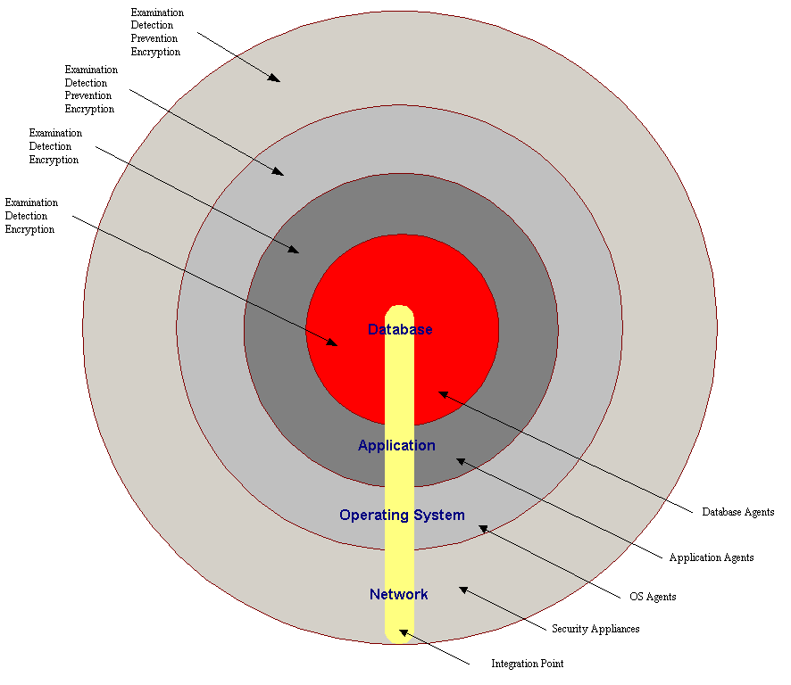

FIG. 1 – SECURITY FUNCTIONS AND TYPES OF PRODUCTS BY COMPUTING LAYER

ACCESS CONTROL PLAN

Layering security products into plant control environments requires identifying “scope of access” for personnel, job functions, and computing environments. Detailed information related to function and accessibility to services is required to correctly configure examination, detection, prevention, and encryption products. Many of these security products utilize rules, signatures, and policies to evaluate, detect, and accept or deny traffic through a network. A layered security model is most effective when it is supported by an access control plan that addresses access in multiple dimensions (i.e. personnel, function groups, computing environments).

An effective access control plan defines electronic access for personnel by primary job function and computing environment. Additionally, an access control plan can further identify access for functional groups that have secondary job functions (development vs. support). Personnel with similar job responsibilities can be grouped by function, which supports segmentation of computing environments according to the functions performed within those environments. Security technology becomes easier to configure and maintain when computing environments can be isolated, and personnel are grouped by job function within those computing environments.

COMPUTING ENVIRONMENTS

Any organization has one or more computing environments to support business activities. In plant control environments there is typically one computing environment focused on controlling the production process, and another computing environment focused on business operations in support of production. In many instances, plants do not segment their computing assets by environment; rather, they implement a single environment with little, or no security.

A layered security model is most effective when separate computing environments can be created, and functions can be isolated by environment. In later-generation plant control environments, there may be multiple layers of control assets with varying levels of criticality. Typically, plant controls are deployed into a single computing environment; however, a plant control environment can be further segmented by criticality to provide an added layer of security.

FUNCTIONAL GROUPS

Grouping personnel according to their job function further supports a layered security model by allowing segmentation of network space by function. Additionally, functional groups can be further controlled by the type, and level of access required within each computing environment. Many organizations group personnel according to a product or service line, which increases the complexity of the security model, especially when functional groups have multiple roles (i.e., development, support). The most effective grouping model is aligned with job functions such as accounting, database engineering, system engineering, human resources, etc. Identifying functional groups in plant control environments is imperative to creating a security model that protects highly critical controls. Additionally, plant control environments are typically well structured to support a functional grouping due to the separation of job responsibility by production process. Further segmentation of plant control environments by criticality can promote further segmentation of functional groups.

ACCESS MATRICES

An access control plan includes a mid-level security policy and set of access matrices. Mid-level policy addresses access to basic computing services such as email, file and print services, and the Internet. Access matrices provide detailed definition on scope of access within a computing environment by employee and function. Access matrices should identify accessibility to other computing environments according to functions and types of services required in those environments. Specifically, access matrices should provide a sufficient level of detail to develop firewall policies, examination rules, signatures for intrusion detection, and VPN points.

COMPARTMENTALIZATION

A common practice in network and security engineering is to compartmentalize network environments. Segmenting a network space into computing environments is one form of compartmentalization; however, further segmentation within a computing environment is where true compartmentalization is effective.

Compartmentalization focuses on segmenting network space to support the introduction of security products such as firewalls and intrusion detection, and to reduce the complexity of policies, signatures, and rule sets. Compartmentalization becomes more effective when job functions can be grouped within a “compartment.”

Plant control environments are typically the most critical environments in an organization; thus, critical environments should not only be isolated from business networks, but also compartmentalized by level of criticality. Figure 2 presents a compartmentalization scheme that incorporates a firewall to segment Plant Controls, Plant IT, Remote Plant Controls, and a DMZ. This level of compartmentalization reduces the complexity of the corporate firewall policy, while reducing the complexity of the plant firewall. The Plant Controls network in Figure 2 can be further segmented to enhance security between the less critical assets (Plant Controls), and those critical assets responsible for basic operation (Critical Controls).

At a minimum, the Plant Controls and Plant IT networks should be compartmentalized to protect the Plant Controls network from access to public networks (i.e., Internet). This architecture allows the Plant IT network to access business services such as Email, Accounting, and the Internet without compromising security in the Plant Controls network. This level of compartmentalization further promotes the use of intrusion prevention, intrusion detection, and examination within each network; thus, creating a layered security structure.

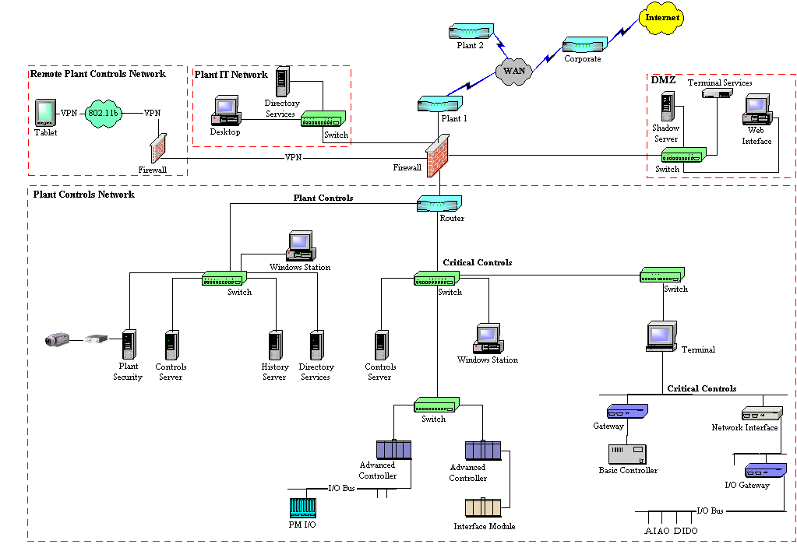

FIG 2. COMPARTMENTALIZING PLANT CONTROL ENVIRONMENTS

IMPLEMENTATION

A layered security model advocates the use of security products at all computing layers; however, there are four basic types of security products that should be part of any layered security architecture: examination, detection, prevention, and encryption. Examination products typically focus on vulnerability analysis, hardening, and tuning of computing assets. Detection products focus on identifying intrusions once they are inside the computing environment. Prevention products focus on preventing unauthorized access to specific networks and hosts according to a pre-defined policy. Encryption products focus on securing data during transmission and storage. While there are many other types of security products used in business, these basic security products should serve as the foundation for an effective security posture.

EXAMINATION

Examination products are commonly referred to as “scanning” technology. Examination is a proactive technique used to identify vulnerabilities in all computing layers before they become compromised. Examination at the network layer operates “in-line” with a network, discovering all assets in a network then identifying vulnerabilities in each asset. Network examination products can be delivered as an appliance, or as software running on a desktop or laptop. Automated appliances are the preferred method of deploying network-level examination.

Examination at the operating system layer provides detailed information about a host by discovering user accounts, and fingerprinting software (i.e. Microsoft IIS) and operating systems. Vulnerabilities can be identified using a pre-defined rules set. Examinations at the operating system level provide more in-depth information about a host than network-level examinations, and are typically deployed as “agents” on each host.

Application and database examinations focus specifically on vulnerabilities with a particular software application (i.e., Microsoft IIS), or database environment (i.e., Oracle). These products are written specifically for a certain software package or database. Examination products focused on software packages and databases provide the most granular level of security in a layered security model.

DETECTION

Detection products are “reactive” in nature because they search for problems that already exist in a computing environment. Detection products can be delivered “in-line” with a network, or at the firewall layer as “Intrusion Prevention” technology where well-known attack signatures are used to detect intrusions prior entering a network.

The most common detection products available today focus on virus detection in email, and intrusion detection at the network and host layer. Detection products are a necessary component of layered security; however, they are only effective when combined with proactive and preventative products in layered approach.

PREVENTION

Prevention products focus on allowing or disallowing entry into a specific network. Prevention products can be as simple as access control lists in a router, or as advanced as stateful firewalls using sophisticated policies to evaluate and gate network traffic.

Firewalls at the network and host layer are common in all environments and use detailed information such as network addresses, host names, and services to evaluate whether traffic is allowed into a specific network. Network-based firewalls are an important security technology for any organization. Firewalls are the first line of defense in a network guarding against unauthorized intrusion.

Many plant control environments are part of a larger corporate network, separated and connected only by routers. One of the first compartmentalization techniques used in a multi-site organization is to implement firewalls at the “edge” to increase intra-site security, while protecting intrusion from the corporate network, and the Internet. Figure 2 demonstrates placement of a single-site firewall to compartmentalize a plant network, and secure against intrusions from other plants and the corporate network. Additional firewalls can be implemented within a computing environment to further secure critical layers within that environment.

ENCRYPTION

Encryption products provide an additional layer of security by addressing data security both in transmission and storage. Encryption involves modifying readable text into a non-readable state that requires technology to decrypt at the destination or delivery point. Many encryption technologies such as VPNs focus on creating a secured transmission medium that prevents interception and deciphering of data during transmission. Other encryption products focus on securing stored data, both in databases and applications.

Encryption technology such as VPNs can be used in a plant control environments to provide secure remote access to critical assets. Specifically, Figure 2 demonstrates how wireless remote control technology can be encrypted through a VPN to allow remote management of critical plant controls. A wireless client incorporates VPN software to establish and transmit through a secured “tunnel” to the plant controls interface on the firewall. VPNs are highly recommended to secure either wire-based, or wireless access to critical assets from remote locations.

CONCLUSION

Layered security is a practice that involves implementing multiple security technologies in each layer of a computing environment to reduce risk of unauthorized intrusion. Exposure to intrusions increases as plant control environments migrate to open technologies such as Ethernet, Windows, and the Internet protocol. Layered security can be accomplished by adopting a “best practices” model, developing and implementing an access control plan, and compartmentalizing the network. At a minimum, plant networks should be compartmentalized by business and control functions. Additional compartmentalization within a controls network can be implemented according to level of criticality. Personnel should be grouped by function and used to further secure a computing environment by restricting access to only the functions performed in that environment. Layered security is a well-documented practice that allows an organization to selectively implement multiple layers of security technology according to its security policy and perceived business risk.

REFERENCES

- MacLeod, Donald and Whyte, David “Towards System Survivability using the Single Virtual Enterprise Model and Layered Security through Information Protection Co-ordination Centres”, A Position Paper, Minister of National Defence, on behalf of Communications Security Establishment, Canada, 2000, Page 2.

- Wells, Mark and Thrower, Woody, “Defend Your Enterprise With Layered Security”, Symantec Advantage, Issue 11, Summer 2002, Page 1.

NOMENCLATURE

Demilitarized Zone (DMZ) - A network used to separate computing assets that are exposed to public networks from internal computing assets.

Virtual Private Network (VPN) – technology that establishes a secured connection or “tunnel” over a network between two computing assets that supports secured and encrypted transmission.

Layered Security - Deployment of security technologies in each layer of a computing environment to reduce the risk of unauthorized access by creating multiple points of resistance, and reducing the risk of failure from a single technology.

